Junior Road Safety Officer

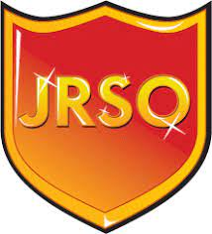

Responsibilities:

- Polite and well-mannered
- Organised and committed
- Good attendance and punctual to school
- Well-presented in uniform and appearance
- Able to talk confidently with staff, pupils and the wider community
- Is a role model for others

Role:
- To create and maintain a Road Safety notice board, keep it up to date with current topics by displaying information for all pupils, teachers and visitors at school to see.
- To arrange and carry out, with support, Road Safety activities/ competitions/ surveys/ role plays etc. using information provided or researched by you.
- To organise School assemblies, lessons and displays at school events based on a Road Safety theme at least once per term, with support and guidance from teachers.
- To ensure that reasonable care is taken at all times for your own and others health, safety and welfare.
- Maintain a JRSO logbook, based on the road safety topics you are covering. Including copies of : Assembly scripts, correspondence, surveys carried out and research done. Also Photographs showing the activities throughout the year with simple explanations
This work record should be to a high standard and Suffolk County Council will use this book to rate the annual award certificate presented to each JRSO and the school.
Pupil Responsibility - Application Form

Name and Class

I would like to be a…..

I would be good at this because….

I have these key skills…..

Any other information you would like to share…

Please hand your completed form to either Mr Lea, Mrs Jones or Mrs Tilley.

