Head Pupil

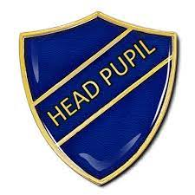

Responsibilities:

- Polite and well-mannered
- Organised and committed
- Good attendance and punctual to school
- Well-presented in uniform and appearance
- Able to talk confidently with staff, pupils and the wider community
- Is a role model for others

Role:

- Represent the school during internal and external events; Christmas Carol service, Remembrance, Harvest, Easter
- Sit on Pupil Council
- Represent the school on Pupil parliament
- Write and read prayers for the Church
- Lead whole school assemblies
- Write for the school newsletter
- Involved in showing visitors around the school

Pupil Responsibility - Application Form

Name and Class

I would like to be a…..

I would be good at this because….

I have these key skills…..

Any other information you would like to share…

Please hand your completed form to either Mr Lea, Mrs Jones or Mrs Tilley.

