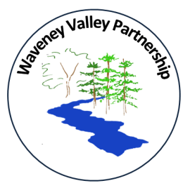
Waveney Valley Partnership

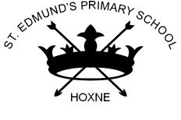


Academy Head, Waveney Valley Partnership – Simon Lea
Email: head.wvp@consortiumtrust.org.uk
Website: http://www.waveneyvalleypartnership.org.uk

14th October 2024

Dear Parents/Carers,

Harvest celebration – Thursday 24th October 2024

As part of our harvest celebrations, we will be holding a harvest service at Mendham Church, on Thursday 24th October 2024 at 9.00 am and everyone is welcome to attend. We will be presenting songs, poetry and artwork and prayers.

As part of the service, we would like to recognise those that may be less fortunate than ourselves and support the local food bank which is based at the Church. We ask that, if it is within your own budget, each child brings a donation for the foodbank of tinned or dried goods with a focus on people who have food intolerances so items which are FREE FROM (examples below). We would like donations to be in school ideally by 23rd October to enable us to drop off at the church ready for the service.

If you would like to head straight to the church after dropping off the children, the kettle will be on for anyone who would like a cup of tea or coffee before the start of the service. FoMSA have also organised a lovely bake sale so you can purchase a cake to have with your drink too so don’t forget to bring some money.

Yours sincerely

Mr Simon Lea
Academy Head




