Trust Drivers and Learning Pi Platform

- Introduction
Trust schools are committed to teaching not only a well-planned and sequenced knowledge curriculum but are also committed to developing the ‘whole’ pupil, including their learning characteristics. The Trust’s Drivers, created collectively with member schools, set out the specific areas of personal development, creative development and community engagement that will be the focus of each schools’ personal development curriculum.

We believe that the Trust’s Drivers are areas of development that are vital for pupils to gain the learning and life skills (characteristics) that they need to go on and lead active and fulfilled lives. We also believe that for pupils to successfully develop in these areas they must be offered explicit and well-planned opportunities both within the formal and informal curricula.

- The Drivers

Personal Development | Creative Development | Community Engagement
Determined and Resilient | Imaginative and Creative | Responsibility
Resourceful | Curious | Participation
Reflective and Self-Improver | Purposeful | Sense of Place
Risk Taker | Adaptive | Engages with Debate
Collaborator | Builds Links | Understands and Respects  Equality and Diversity
Independent Learner | Independent Thinker | Respectful, Active Citizens

  - Embedding the Drivers
The Drivers are deliberately embedded in to the curriculum, classroom practice and in all learning conversations, the Drivers are also visible in all school areas including office and staff rooms.

Throughout the curriculum Drivers are explicitly planned for in long-term plans as well as unit plans for specific subjects. Through monitoring by school leaders, Trust central team members and external bodies the effectiveness of the plans will be captured and where necessary schools are supported to develop their approach to developing learning characteristic for all pupils.

The Trust’s 5-year strategic plan is framed by the Drivers. The key performance indicators have been created to ensure that development in all areas of the Drivers are an expectation for all members of the Trust community and are integral to any new developments.

- Pi Personal Improvement – Learning Platform

3.1 Intent
It is intended that the platform will provide a hub for pupils, parents and teachers to discuss, evaluate and plan for development in each of the Trust Drivers.

3.2 Teachers will be able to use the information provided on the platform to explicitly plan for learning experiences that pupils need to develop, individually, in small groups or as a whole class. Learning opportunities can be allocated to pupils as part of their current unit of study, class theme or topic, or pupils can have activities allocated to enable them to reflect on and develop a specific area of the Drivers. Teachers can also be able to set learning opportunities as homework to support individual development.

3.3 Parents will be able to view the latest information about their child including their current academic assessment in reading, writing, maths and, at the end of each year, science. The Pi will provide parents with information about their child’s development in the Trust Drivers and Learning Characteristics as well as view and select learning opportunities that have been allocated to be completed. Parents will be able to support their child in reviewing their own development and begin to discuss areas for improvement and reflections on experiences to date. It is intended that parents will have a greater involvement in their child’s personal development and be able to support their development by using the platform to have learning conversations at home.

3.4 Pupils will be able to view the latest personal information and view learning opportunities that have been allocated to them by their teacher (or another adult at school). Pupils, with support from parents/carers, will be able to upload evidence against an allocated learning experience as well as enter a reflective log. It is intended that as pupils become familiar with the learning platform that their ability to reflect on the intended learning will become more fluent and that this will enhance the learning that takes place.

- Implementation

4.1 Pupils each have a personal login to their page where they are able to view their learning profile. The profile focuses on development in the Trust Drivers and Learning Characteristics, as well as including current academic attainment and progress. Pupils are expected, and supported, to use the platform regularly and routinely.

4.2 Teachers plan explicitly for the Trust Drivers and Learning Characteristics and should be considered for all lessons and subjects. The Learning Characteristics are selected to enhance learning experiences and will be most successful when embedded into learning. To support the language of personal development and effective pupil self-reflection children are encouraged to identify the relevant Learning Characteristic in all learning experiences.

4.3 Pupil Personal Improvement. Drivers and Learning Characteristics are used to support pupil’s personal development and pupils are supported to reflect on their own learning experiences rather than making comparisons to other pupils. At all ages, pupils should be encouraged to reflect on their own development, experience and begin to use developmental observations about what they could improve in the future. Staff use deliberate language to explicitly discuss development. For example, pupils will be supported to understand that we can learn through trial and error and taking risks and will be supported to identify when learning experiences have taken place and the processes they have been through to be a successful learner.

- The Pi

5.1 Intent
The Pi indicates where a pupil has completed learning activities designed to explicitly develop one of the Learning Characteristics. The intent is that pupils build up each layer of the Pi rather than a slice.

Examples of a pupil Pi being developed

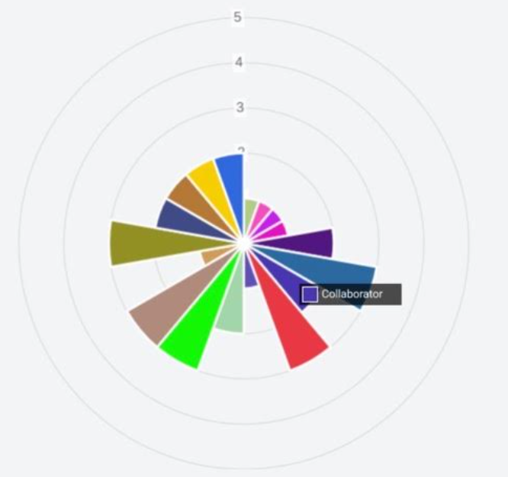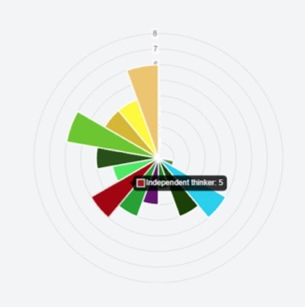

5.2 Implementation
By reviewing the Pi with a member of school staff or someone at home the pupil is able to reflect on areas that they should consider developing. Pupils have ‘Open Activities’ assigned to them that they can choose to complete at any time, they also have activities assigned as homework that are either allocated following a review of their Pi or as part of a curriculum unit of study.

5.3 Impact
By focusing on the development of their Pi throughout their time at primary school pupils develop a well-balanced set of learning characteristics as well as an understanding and engagement in a wider community.

- Pi Personal Improvement – at THIS SETTING
At Waveney Valley Partnership the learning Pi characteristics and language are embedded into every lesson. Explicit links are made between the subject specific learning and the characteristics being used in the individual lesson, this is evident in learning objectives.
The school has a focus characteristic each fortnight, which is introduced in a whole school assembly and examples of this within school are then celebrated and displayed on our whole School display board. This work is then retained in a floor book to allow progress and work to be celebrated.

- Educational Research
Educational research took place in the Autumn and Spring term of 2020-21. The purpose of this research was to write a specific criteria for each of the sixteen Learning Characteristics that make up the three Drivers. Each Learning Characteristic was then broken down into three Milestones that are linked to Key Stage 1, Lower Key Stage 2 and upper Key stage 2.

The research included looking at authors and educationalists such as Guy Claxton, Paul Tough, Ken Robinson, Howard Gardner, Deborah Kidd and Tom Sherrington. Guy Claxton’s ideas around ‘Learning Powers’ and resilience were a key driver alongside Paul Tough’s work on ‘performance character’. We also looked at how schools internationally and nationally developed character, such as KIPP and High Tech High alongside as XP School in Doncaster.

This research was then collated to write the above mentioned three milestones and then linked directly to Developmental matters to ensure we showed progression of our Learning Characteristics from Early Years up to Year 6. Each Activity planned on Learning Pi is then linked directly to a Learning Characteristic and one of its three milestones so that each activity allows the children to develop a specific Learning Characteristic taken from our Trust’s Drivers.

Appendix
Criteria
When attempting activities, a well-formed characteristic of learning involves being ready, willing and able to:

Personal Development | 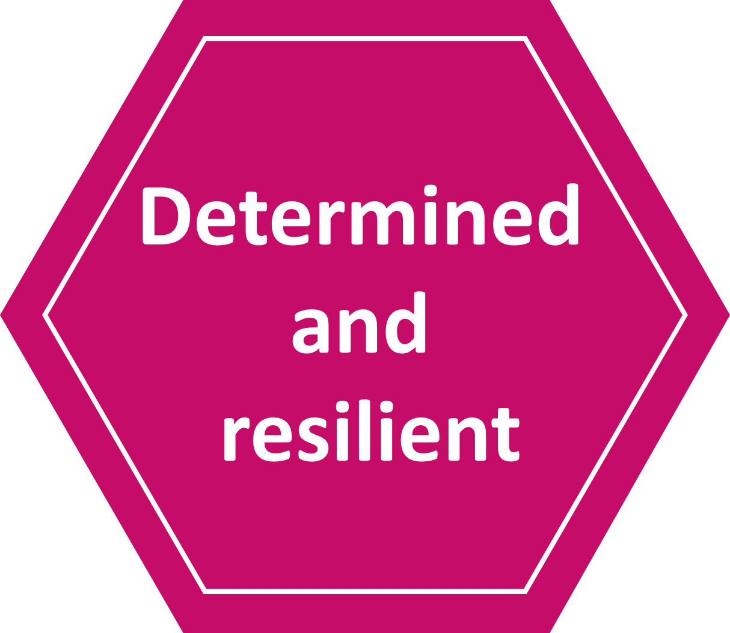 |  | 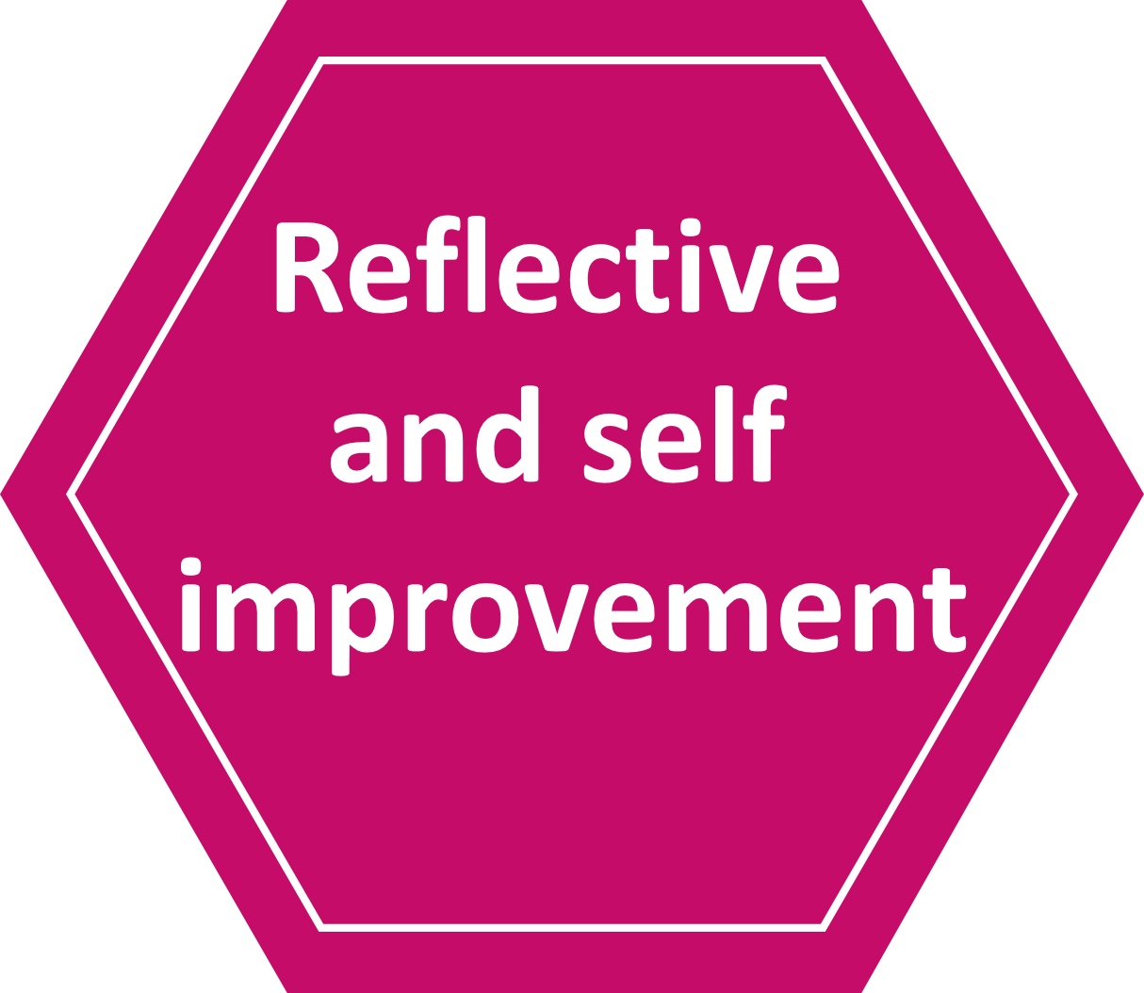 | 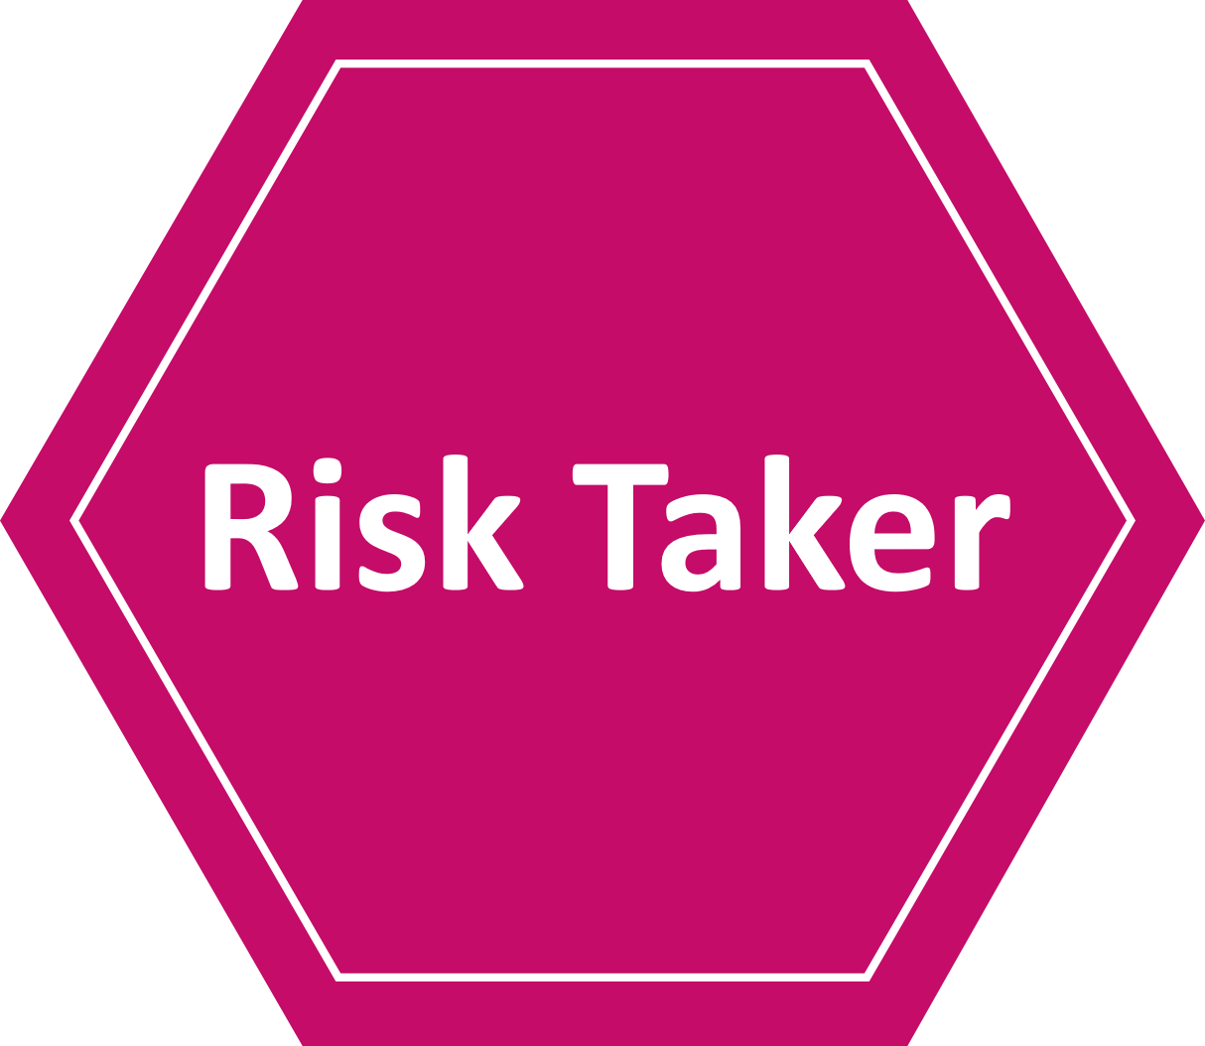 | 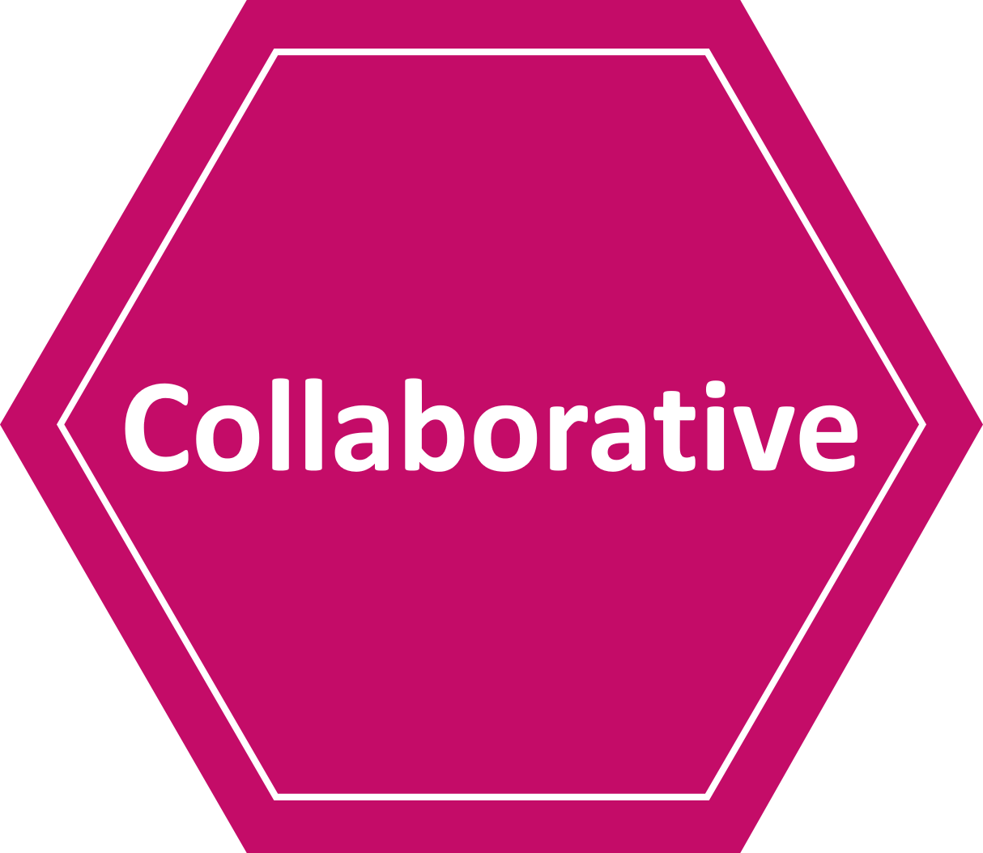 | 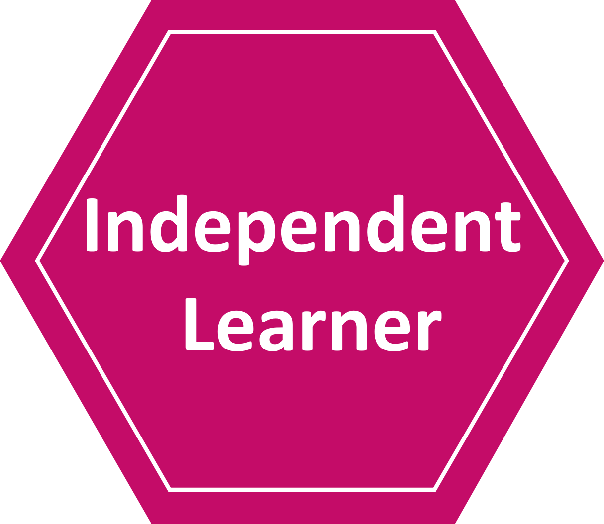
Developmental Matters | •Keep on trying when things are  difficult.  •Show resilience and  perseverance in the face of  challenge. | •Use a range of strategies to reach a goal they have set themselves. | •Review their progress as they  try to achieve a goal.  •Begin to correct their mistakes  themselves. | •Take supported risks, appropriate to themselves and the environment. | •Create collaboratively, sharing ideas, resources and skills.  •Express their feelings and consider the feelings of others. | •Make independent choices.  •Do things independently that they have been previously taught.
Milestone 1 | • Try again with the help of others.  • Carry on until they succeed, even if they feel frustrated.  • Relish working towards goals without fear of ‘failure’. | •Make choices about resources that can help them learn with support.  •Take time to consider different strategies to reach a goal. | •Know their strengths as a learner.  •Know their areas to develop as a learner.  •Identify mistakes and self-correct with support.  •Begin to discuss and refer to their own ‘Learning characteristics.’ | •Take risks in a safe environment.  •Decide if something is safe or not.  •Try something even if they are not sure it will work. | • Listen to others and adapt plans to include other’s ideas.  • Share their ideas with others.  • Take on a role in a group.  • Be patient and wait their turn.  • Manage their feelings and consider the feelings of others. | •Decide when to work independently.  •Plan, complete and evaluate a task.  •Decide where and when they work productively
Milestone 2 | • Develop strategies to overcome failures, setbacks or feeling ‘stuck’.  • Bounce back after a disappointment or failure.  • Show the ability to stick at an activity or area of interest.  •Recognise that being stuck is the  point at which new learning begins. | •Learn from many different sources - people, books, the Internet, music, the environment, experience.  •Independently choose resources to help them learn at any given time.  •Use different strategies to reach a goal. | •Understand their own creative talents and how best to make use of them.  •Discuss how they learn as a person.  •Actively look for mistakes and correct them.  •Confidently discuss and refer to their own ‘Learning characteristics.’ | •Use the phrases “Let’s try this..”  “What If..”  •Actively pursue a challenge.  •Be prepared for something not to work or go as planned. | • Work with and listen to others.  • Share opinions and ideas.  • Take on different roles in a group.  •Begin to see others perspectives.  •Give and receive feedback.  •Be aware how they respond to others and adjust their responses as necessary. | •Work and think systematically.  •Anticipate how long a task will take and plan their time effectively.  •Draw out useful lessons from experiences.  •Consider what they want to get out of the learning.  •Begin to identify which ‘Learning characteristics’ they need to use to complete a given task.
Milestone 3 | • Find alternative ways if the first attempt does not work.  • Stick at an activity even in the most challenging of circumstances.  • See possibilities and opportunities even after a disappointment.  •Relish challenging goals. | •Use a range of techniques for communicating by different means.  •Be proactive in their choice of resources to support their learning.  • Evaluate the use of strategies to reach a goal. | •Discuss their own strengths and areas to develop and actively seek out ways of improving.  •Carefully consider how they could improve if they did something a second time.  •Evaluate their own learning characteristics continuously working on ways to develop them further. | •Have strategies in place that help manage risk and uncertainty.  •Be optimistic and show enthusiasm for a new challenge.  •Not be afraid of making mistakes. | • Work effectively with others toward common goals.  • Hold and express opinions coherently, compromising when appropriate.  • Adopt different roles and responsibilities in pursuit of a shared goal.  • Act proactively and responsibly and use initiative. | •Enjoy and love learning for its own sake.  •Review their progress and change direction if necessary.  •Manage their own learning time.  • Identify which ‘Learning characteristics’ they need to use to complete a given task successfully.
When attempting activities a well-formed characteristic of learning involves being ready, willing and able to:

Creative Development | 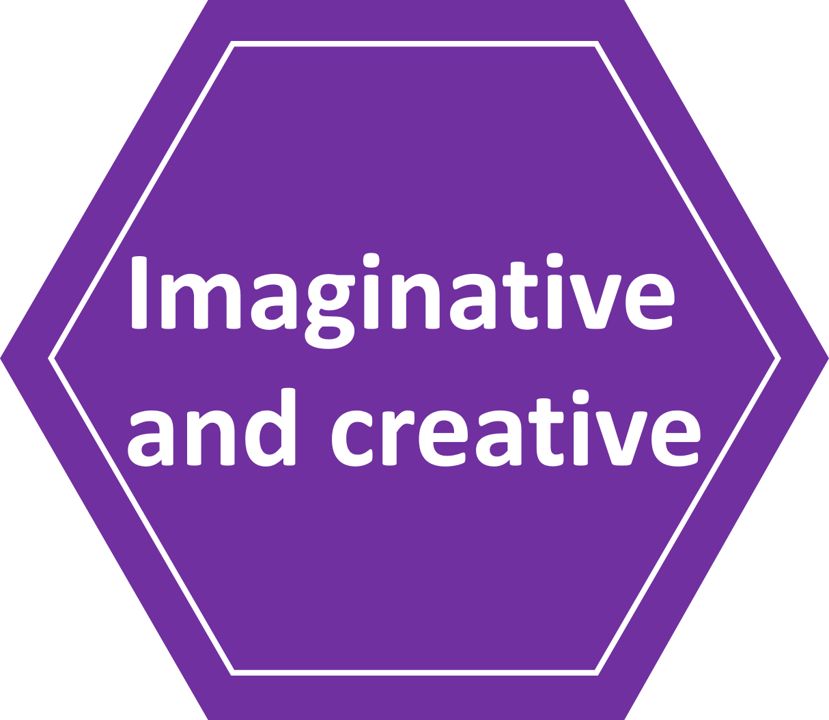 |  | 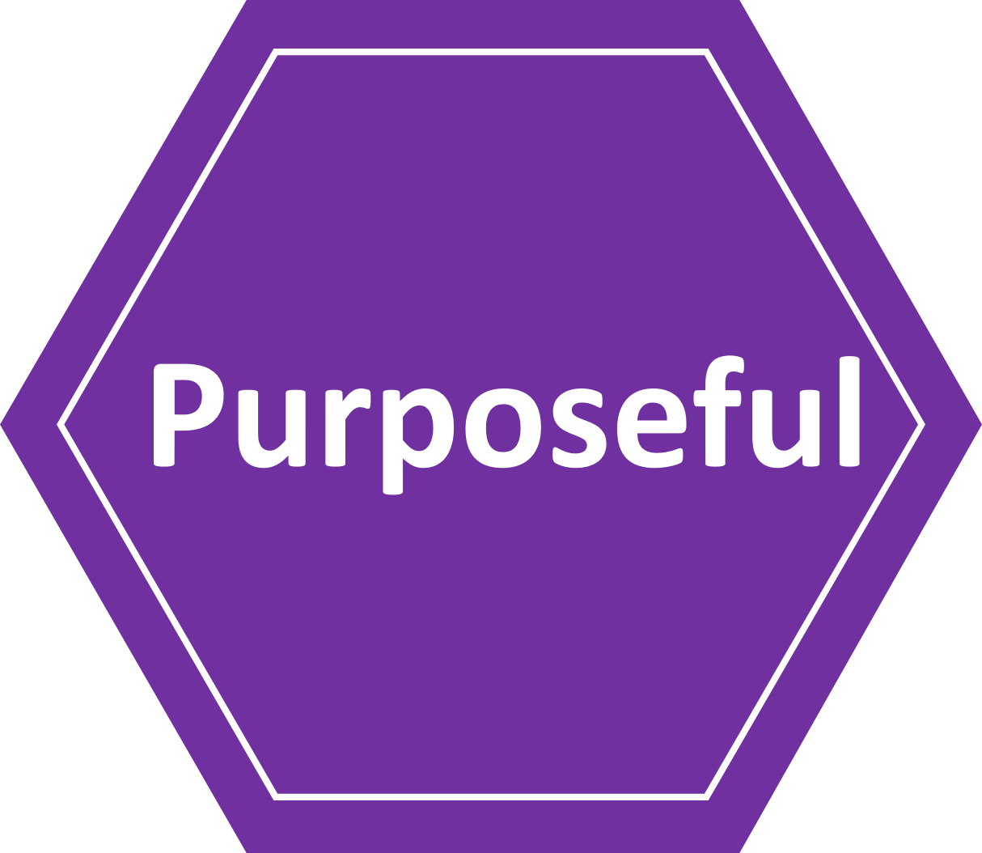 | 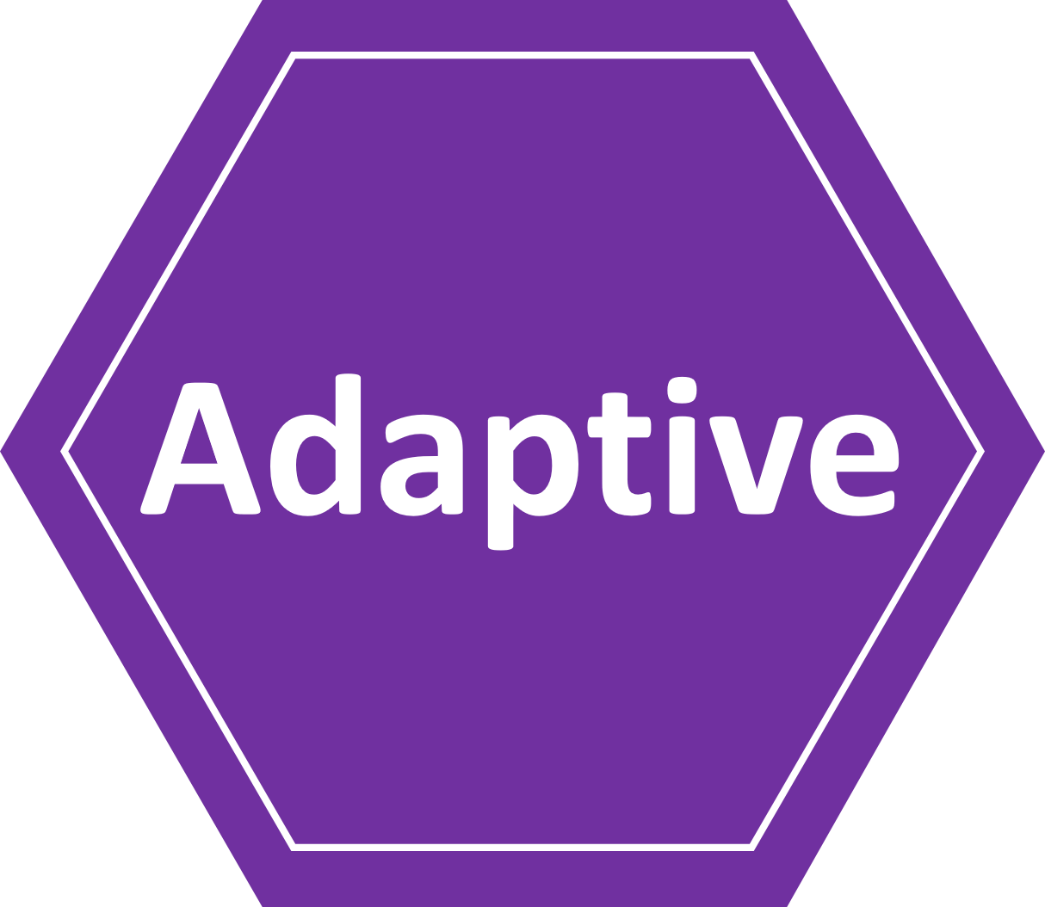 | 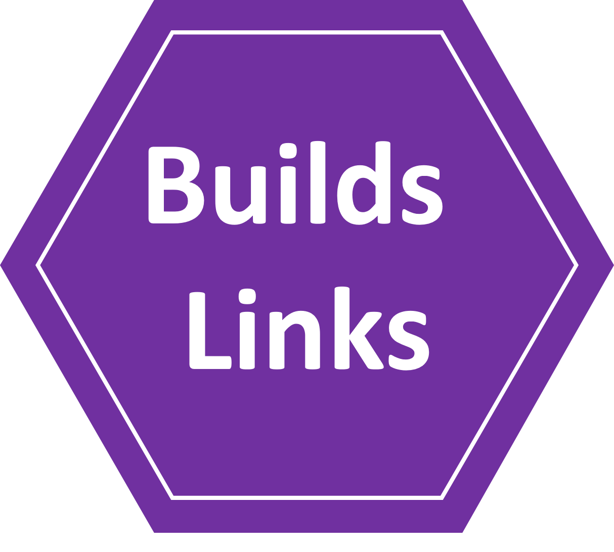 | 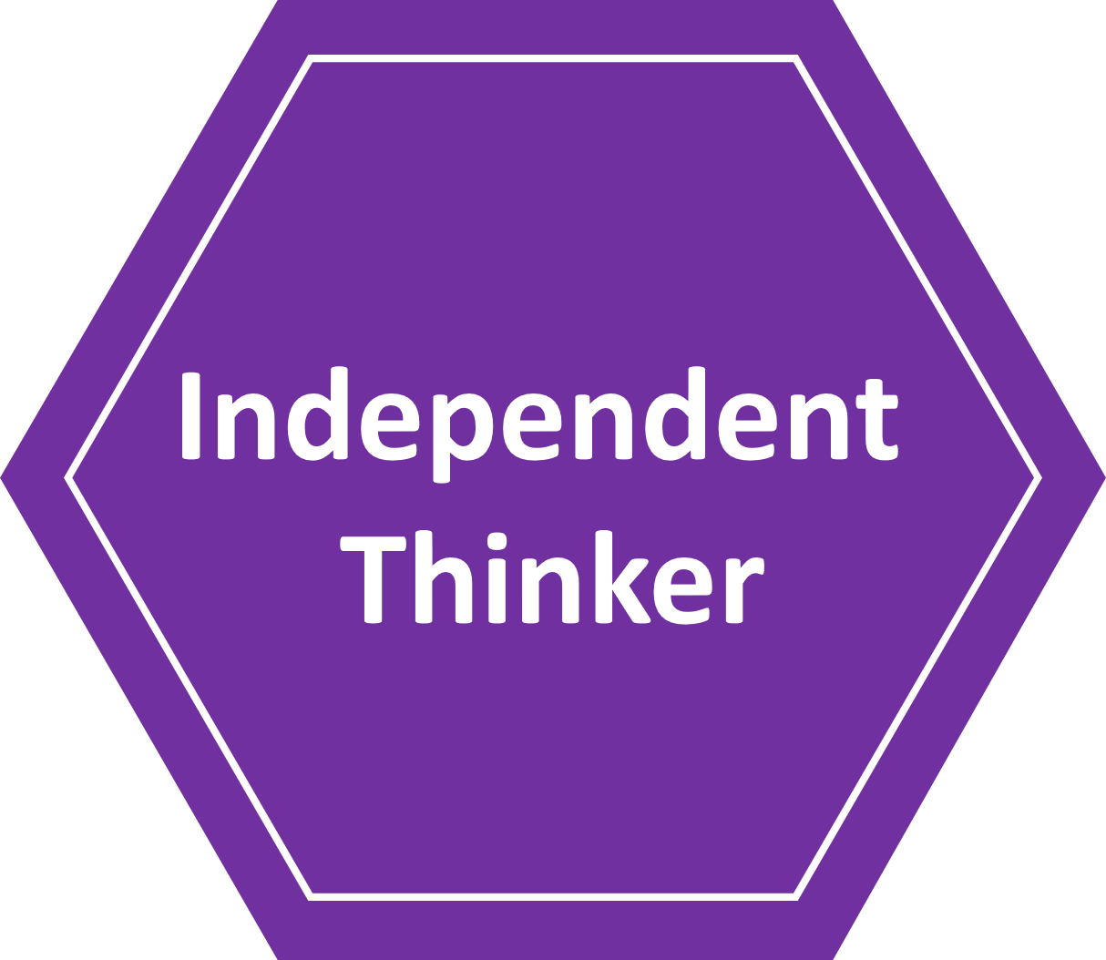
Developmental Matters | •Take part in simple pretend play.  •Use their imagination as they consider what they can do with  different materials. | •Ask questions to find out more. | •Concentrate on achieving  something that’s important to  them. They are increasingly  able to control their attention  and ignore distractions.  •Solve real problems | •Return to and build on their  previous learning, refining  ideas and developing their  ability to represent them. | •Make more links between ideas.  •Connect one idea or action to  another. | •Children find their own way to do things.
Milestone 1 | • With help, develop ideas.  • Respond to the creative ideas of others’.  • Respond to questions about their ideas.  • Using ideas, carry out a creative project. | • Show curiosity when exploring new things.  • Ask probing questions.  • Attentively listen to others to find out more. | •Be focused and engaged in their learning.  •Identify and manage distractions with support.  •Follow simple directions.  •Consider purpose and audience. | •Try an idea and if it is not successful, adapt the idea with support.  •Try out different ideas to see alternative outcomes.  •Plan ideas and change when necessary. | •Identify and talk about patterns, similarities and differences they find.  •Make simple connections between ideas.  •Make links between new and prior learning. | •Ask ‘why’ to find out more.  •Generate their own ideas.  •Predict what might happen.
Milestone 2 | • Picture how things might look, sound, feel, be.  • Ask questions in order to develop ideas.  • Show enjoyment in trying out ideas. | •Enjoy exploring new things.  •Ask and answer questions such as “What if..”  “How come?”.  •Listen to others with interest. | •Be prepared and ready to learn.  •Be focused on learning and manage distractions.  •Identify purpose and audience and plan for them. | •Plan ideas and consider changes that you may need to make.  •Try an idea and adapt if it is not successful.  •Try out a range of different ideas to see what the outcome is. | •Look for connections between experiences or ideas.  •Find pleasure in seeing how ideas and themes fit together and link to bridge our learning.  •Make clear links between new and prior learning. | •Create logical arguments.  •Look for evidence.  •Make their own conclusions based on what they already know.  •Spot flaws in other people's arguments.  •Deduce what might happen.
Milestone 3 | • Let your mind explore and play with possibilities and ideas.  • Know which ideas are useful and have value.  •Consider new ways of approaching challenges.  • Act on ideas.  • Ask lots of questions. | •Be eager to explore new things and knowledge.  •Use knowledge gained from asking questions to show a deeper understanding.  •Listen to others with interest and critically respond. | •Be prepared and ready to learn in all situations.  •Pay attention and resist distractions.  •Start work right away rather than procrastinating.  •Follow through work to completion. | •Think ahead to possible adaptations that may be needed to an idea.  •Experiment with a range of ideas constantly thinking about what you could change or improve.  •Evaluate a completed task considering what to change next time. | •Connect new ideas to how they think and feel already.  •Look for analogies in their memory that will give them a handle on something complicated.  •Make specific connections between learning across subjects. | •Not be afraid of not knowing.  •Get below the surface of things and come up with their own conclusions.  •Use deduction and inference to make predictions.

When attempting activities a well-formed characteristic of learning involves being ready, willing and able to:

Community Engagement Criteria | 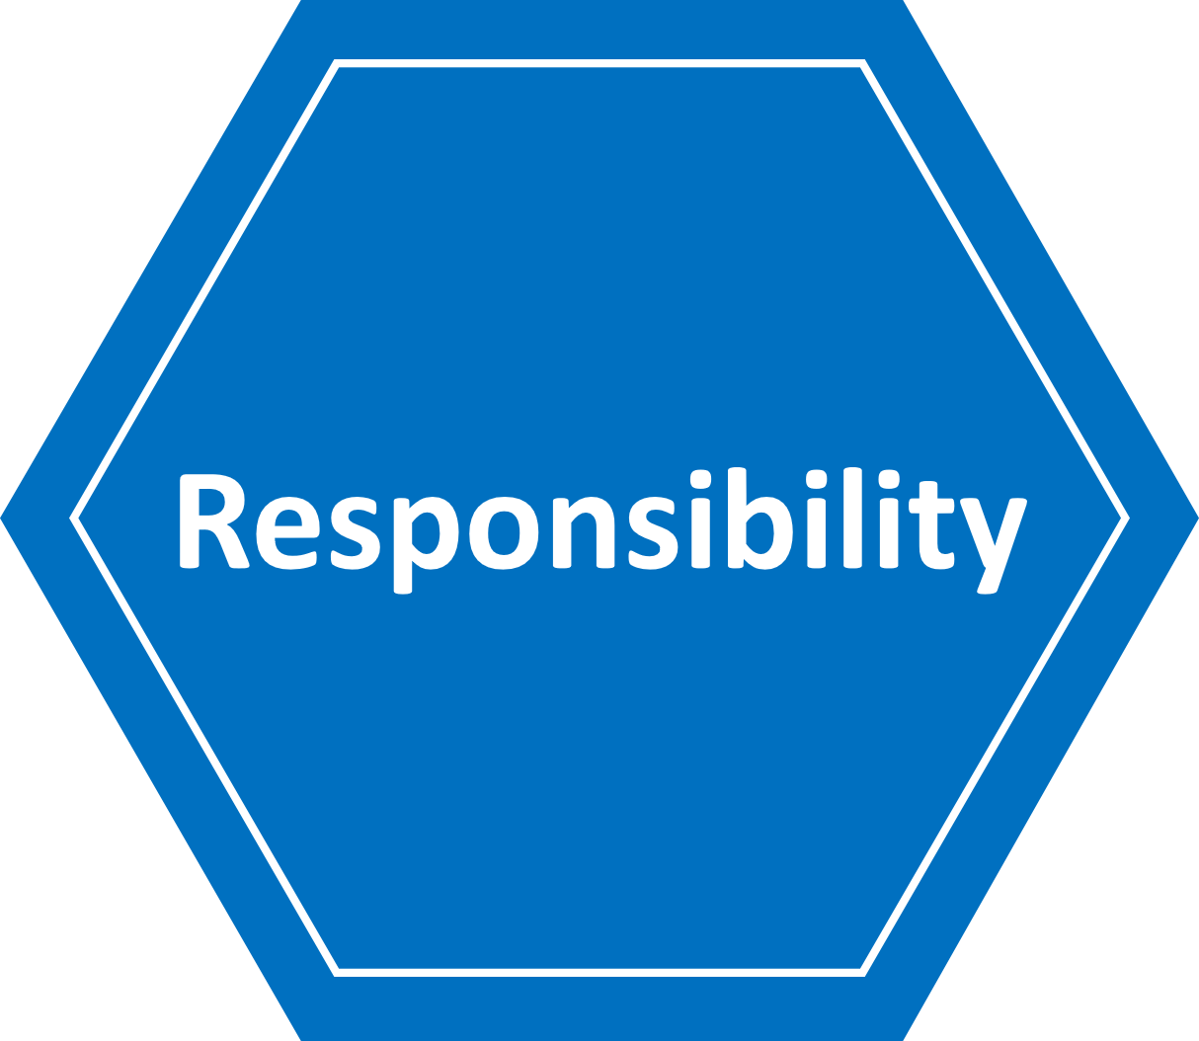 | 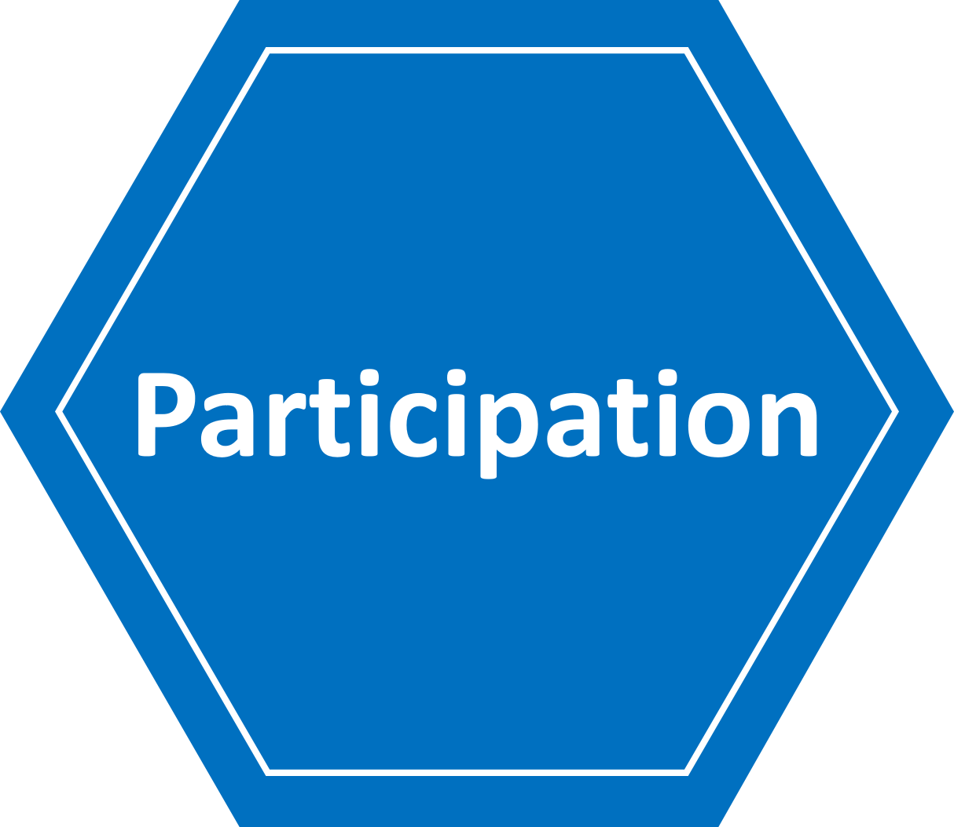 | 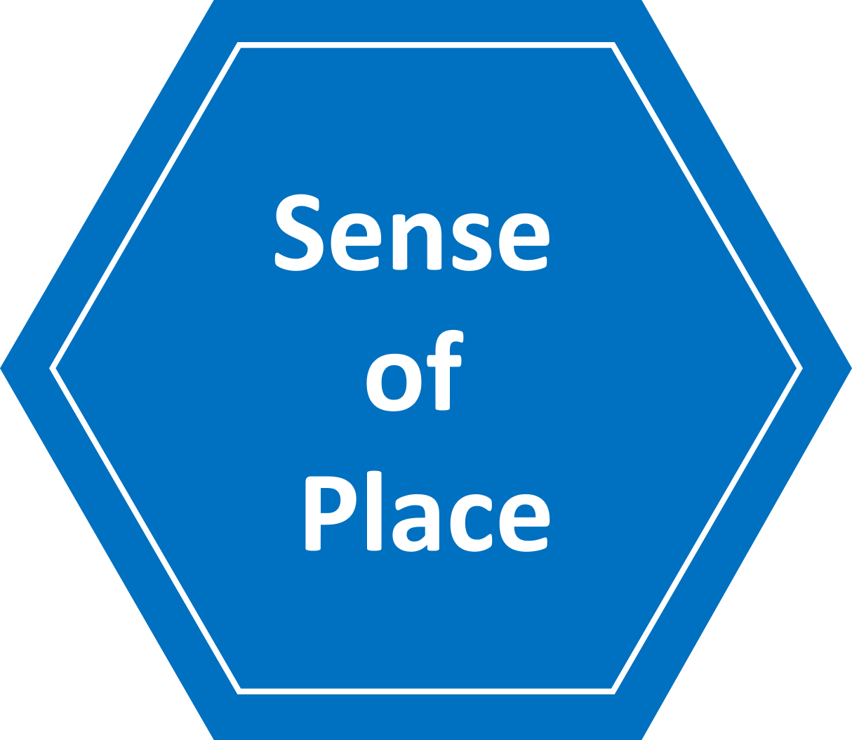 |  | 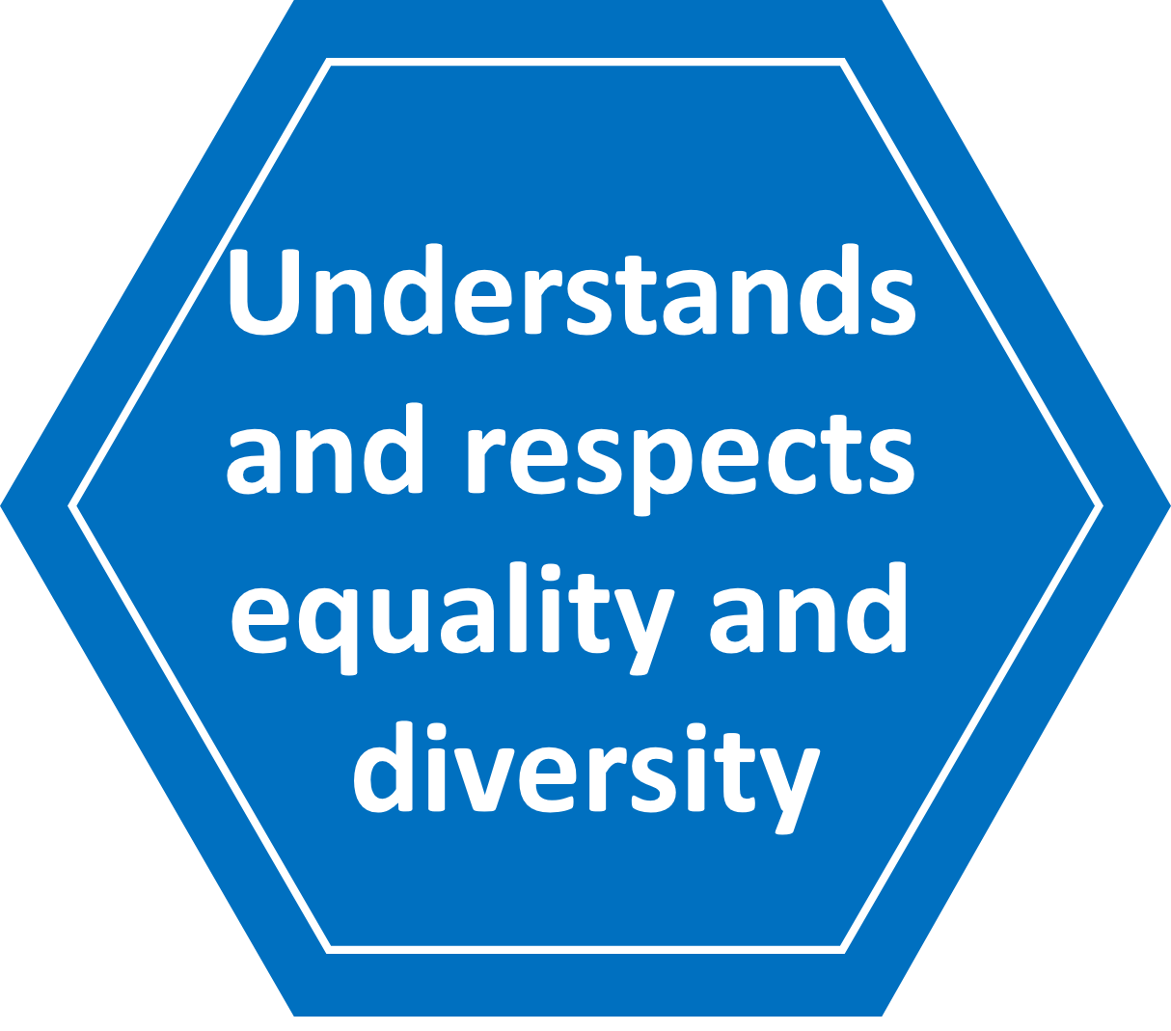 | 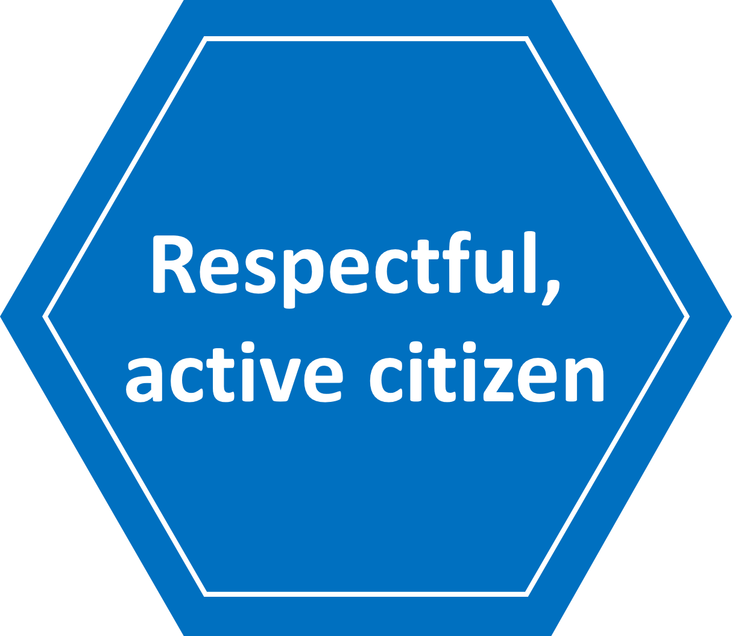
Developmental Matters | •Manage their own needs.  •Identify and moderate their  own feelings socially and  emotionally. | •Share their ideas in whole-class and small group work.  •Build constructive and  respectful relationships. | •Talk about members of their  immediate family and community.  •Understand that some places  are special to members of  their community. | •Think about the perspectives  of others. | •Recognise that people have  different beliefs and celebrate  special times in different ways. | •See themselves as a valuable  individual.  •Express their feelings and  consider the feelings of others.
Milestone 1 | •Work independently and finish a task within a time frame.  •Be responsible for their learning environment.  •Accept that their actions can positively and negatively impact others. | • Contribute in class and at home by taking on extra responsibilities.  •Be focused and engaged in their learning.  •Maintain and embed relationships with their peers and adults in school. | •Interact with and make positive changes to their environment both at home and school.  •Contribute to whole class projects.  •Begin to contribute to the wider school. | •Have an opinion on simple topics.  •Listen to others opinions and take on other’s ideas.  •Use facts to support opinions on topics. | •Respect, recognise and value differences.  •Understand that everyone has equal value. | •Have an awareness of the diversity of British society and different social choices.  •Use Pupil Parliament/School Council to develop understanding of democracy.  •Be respectful of their peers and other members of the school.
Milestone 2 | •Support themselves, their peers and others in school with learning.  •Take an active role in improving their learning environment.  •Create success criteria for a task, project or activity. | •Begin to contribute to wider school by taking on extra responsibilities such as librarians, lunchtime helpers.  •Be actively engaged in their learning and class.  •Have secure relationships with their peers and adults in the school. | •Explore their local area and community.  •Contribute to whole school projects.  •Begin to understand the historical and geographical context of their local area. | •Research facts to support opinions.  •Listen to others opinions and respond thoughtfully.  •Present an opinion orally. | •Talk about equality and human rights.  •See diversity as a strength which should be respected and celebrated. | •Develop an interest and motivation in social and political issues in global society.  •Contribute to in-school democracy.  •Be respectful to others both in school and outside of school.
Milestone 3 | •Support and develop their peers and other members of the school with learning.  •Show accountability by willing to be different and to stand out.  •Make responsible decisions both in and out of school. | •Contribute to wider society by: volunteering, fundraising, organising campaigns.  •Be actively engaged in their learning and school.  •Develop confidence in speaking with visitors and adults in positions of responsibility. | •Explore and promote their local area and community.  •Show pride in their community and school.  •Understand the historical and geographical context of their local area. | •Structure arguments and reasoning.  •Know when to offer counter arguments.  •Present an argument orally using expression, body language and tone. | •Understand cultural and community diversity in both national and global contexts.  •Be confident to challenge stereotyping and prejudice. | •Demonstrate an understanding of ethics and values  and how these inform personal behaviour.  •Contribute positively to the local community.  •Understand the meaning of respect and actively model how to show it.

Document Control

Changes History
Version | Date | Amended By | Details of Change
1 | 13/06/2022 |  | New Policy

Approval
Name | Job Title | Signed | Date
Andrew Aalders-Dunthorne | Principal/CEO | Electronic signature | 13/6/2022
Dawn Carman-Jones | On behalf of the Trust Board | Electronic signature | 13/6/2022

Equality Impact Assessment
Date | Name | Details

END OF DOCUMENT

